**Mastering Embedded System Online Diploma**

[www.learn-in-depth.com](http://www.learn-in-depth.com)

**First Term (Final Project 1 )**

**Eng. Mostafa AboSalama**

**My Profile:** [My Progress Page](https://www.learn-in-depth-store.com/certificate/mostafaabosalama661%40gmail.com)

**Table of Contents**

1. Requirements
2. Requirement Diagram
3. System Analysis
   * Use Case Diagram
   * Activity Diagram
   * Sequence Diagram
4. System Design
   * Module Descriptions
   * State Machines
5. Embedded C Code Modules
   * .c & .h files for each module
   * Makefile, Startup.c, Linker.ld
6. Simulation and Results
   * Description and images
7. Software Analysis
   * .map file, Symbols Table, Section Tables

**1. Requirements**

The client specifies that the system should trigger an alarm when the pressure in the cabin exceeds 20 bars. The alarm should last for 60 seconds.

**2. Requirement Diagram**

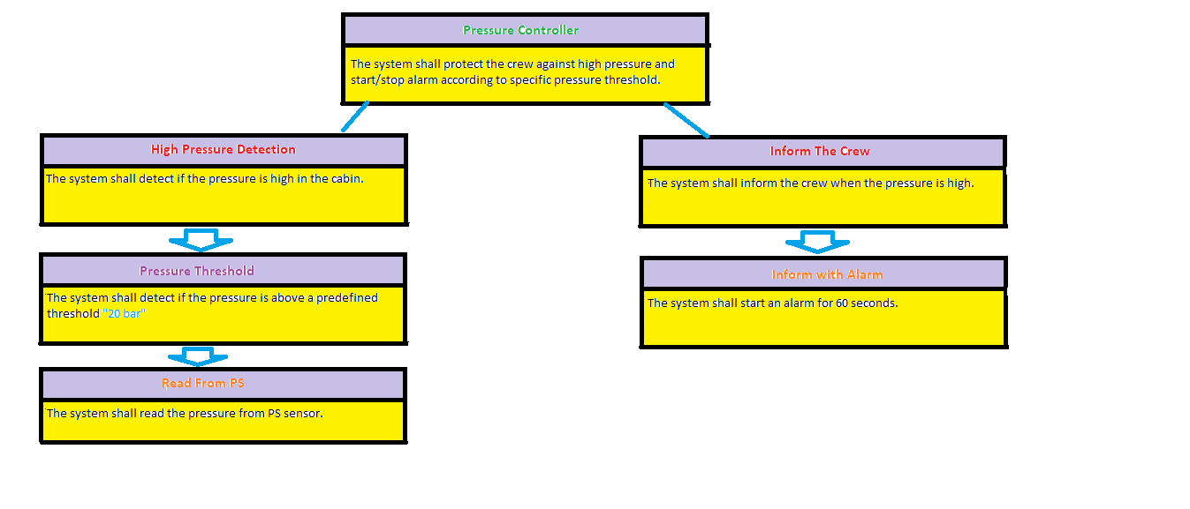

**3. System Analysis**

**Use Case Diagram:**

* The pressure sensor measures cabin pressure.
* If pressure > 20 bars, an alarm is triggered for 60 seconds.
* The crew is informed visually and audibly.

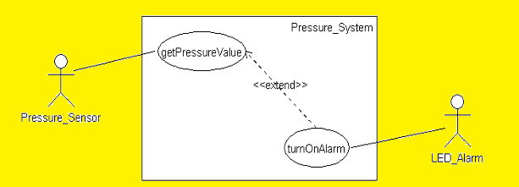

**Activity Diagram:**

* Measure pressure → Check if > 20 bars → Trigger alarm → Wait 60 seconds → Reset alarm.

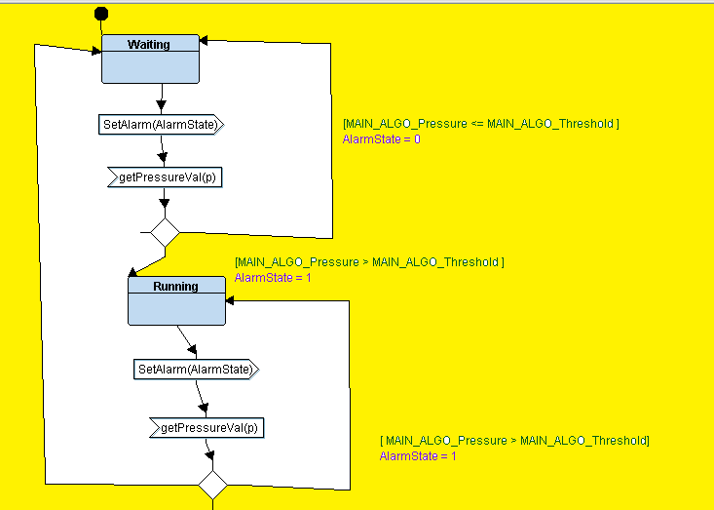

**Sequence Diagram:**

* Pressure Sensor → Microcontroller → Alarm Actuator (if pressure > 20 bars).

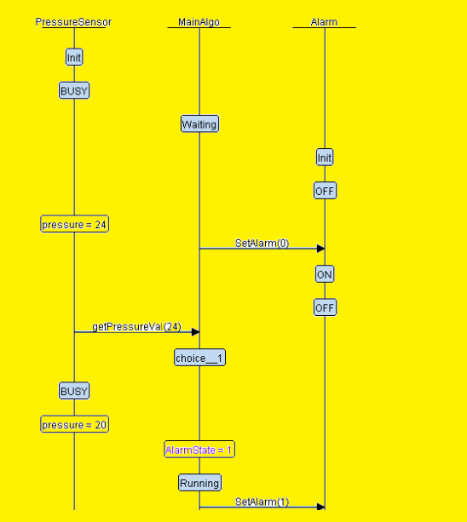

**4. System Design**

**System Block Diagram:**

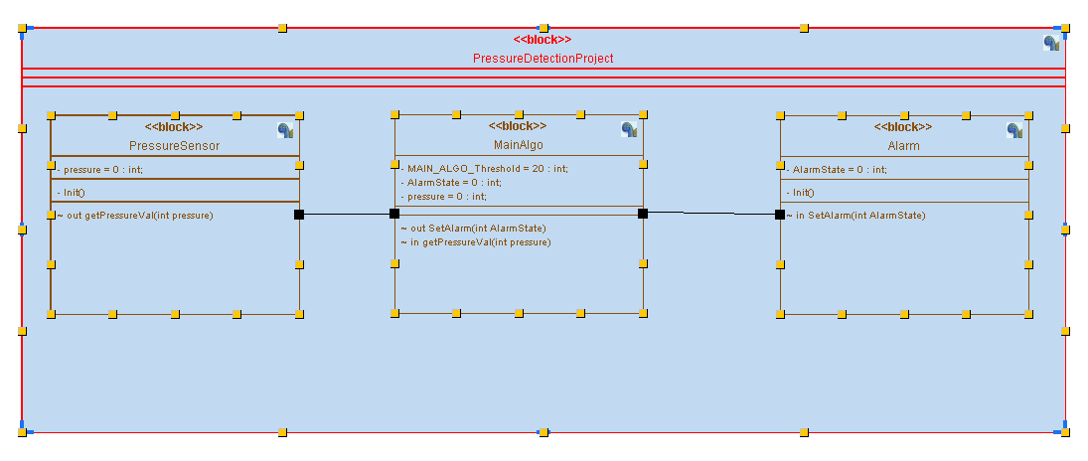

**State Machines:**

1. Main Algorithm State Machine

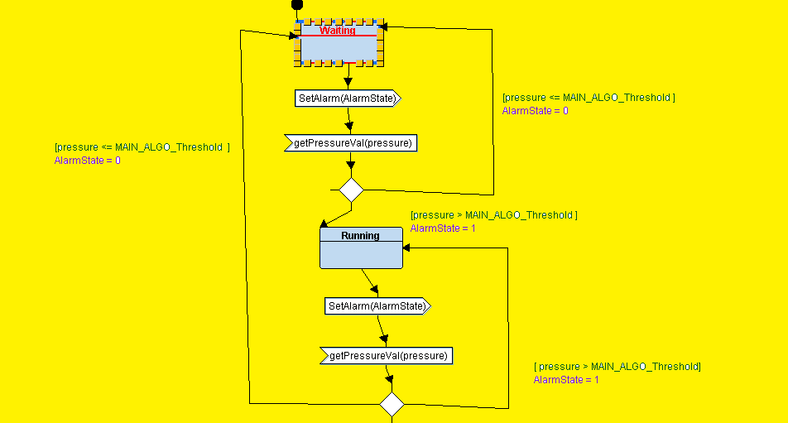

1. Pressure Sensor State Machine

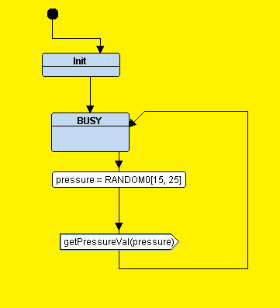

1. Alarm State Machine

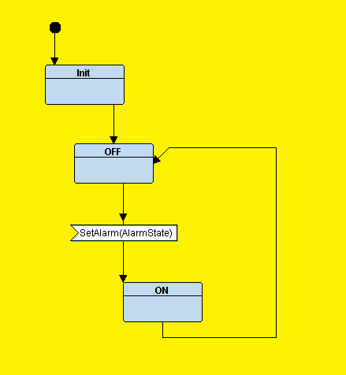

**5. Embedded C Code Modules**

Provide .c and .h files for each module, Makefile, Startup, LnkerScript:



**6. Simulation and Results**

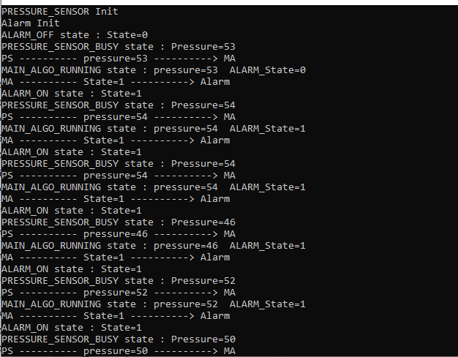

* **Pressure < 20** 🡺 **Alarm Off**

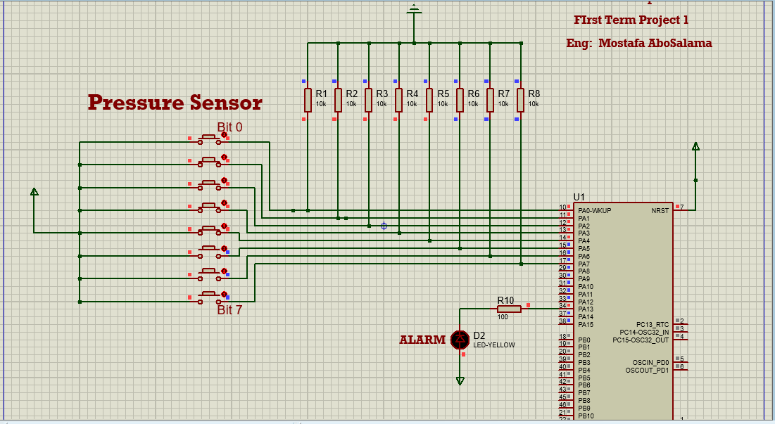

* **Pressure < 20** 🡺 **Alarm On**

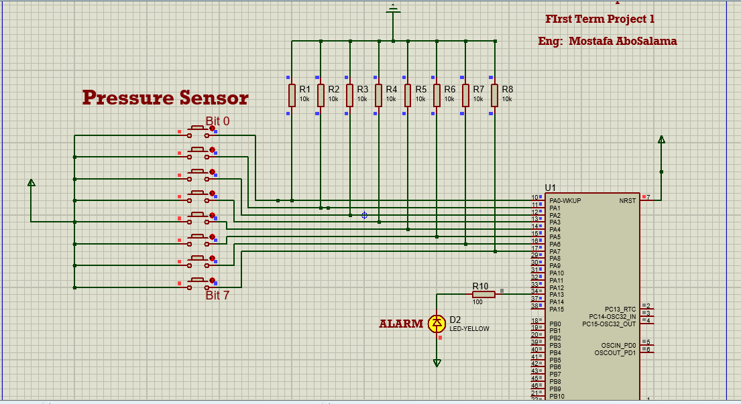

**7. Software Analysis**

* **.map file**

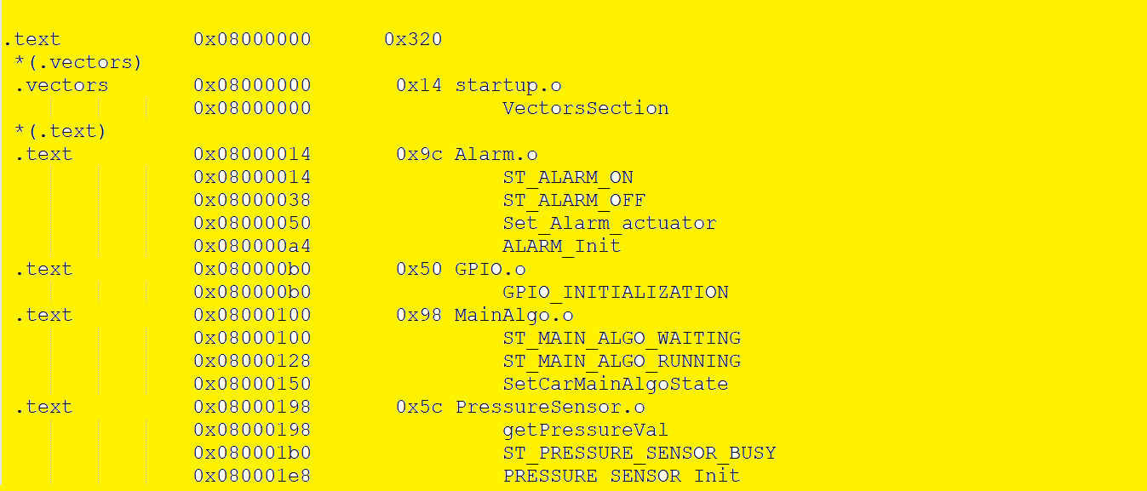

* **Symbols Table**
  1. Main

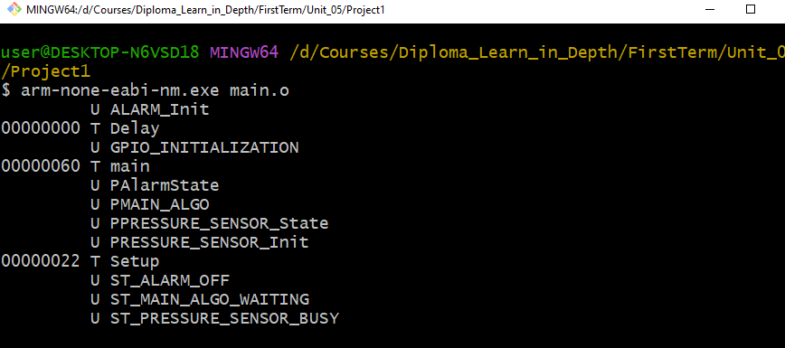

2- Main Algorithm

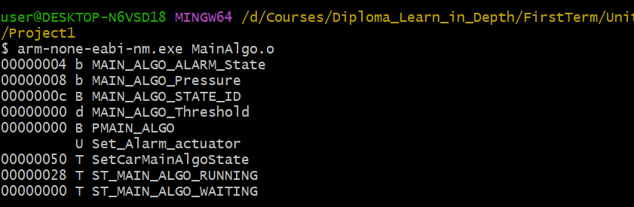

3-Pressure Sensor

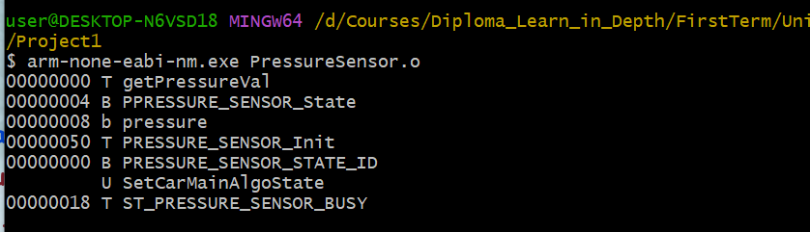

4-Alarm

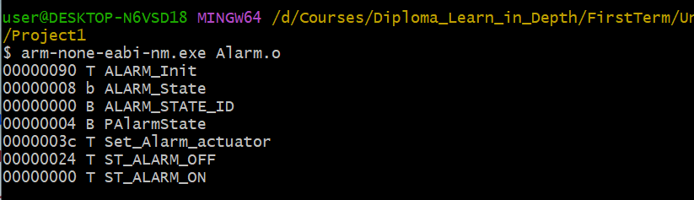

* **Section Tables**
  1. Main

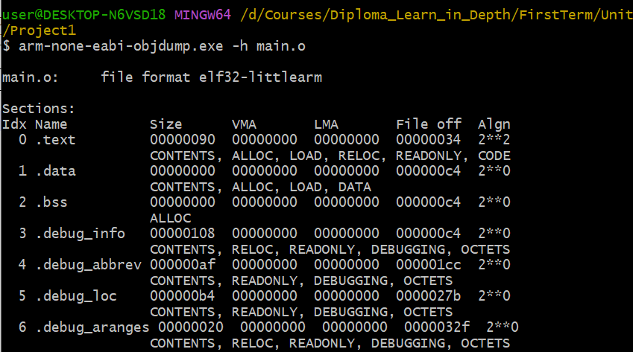

2-Main Algorithm

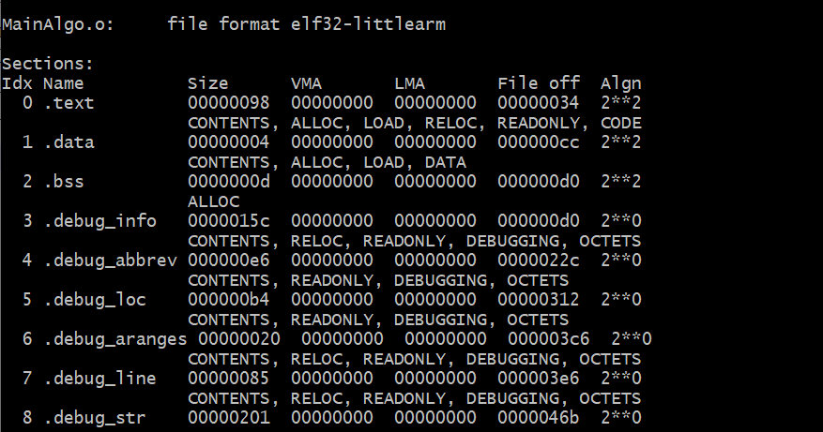

3-Preesure Sensor

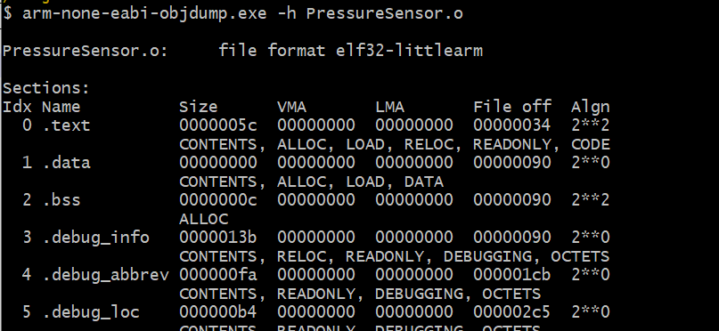

4-Alarm

